A

Major Project On

## SOIL AND LAND CLASSIFICATION

(Submitted in partial fulfillment of the requirements for the award of Degree) BACHELOR OF TECHNOLOGY

in

INFORMATION TECHNOLOGY

BY

Rohith Beravelli (177R1A1214)

SaiRam Maddela (177R1A1224)

Chaithanya Pilli (177R1A1233)

Under the Guidance of

Dr.B.Laxmaiah

(Associate Professor)

## DEPARTMENT OF INFORMATION TECHNOLOGY

**CMR TECHNICAL CAMPUS**

**UGC AUTONOMOUS**

(Accredited by NAAC, NBA, Permanently Affiliated to JNTUH, Approved by AICTE, New Delhi)

Recognized Under Section 2(f) & 12(B) of the UGC Act.1956,

Kandlakoya (V), Medchal Road, Hyderabad-501401.

**2017-21**

## DEPARTMENT OF INFORMATION TECHNOLOGY



**CERTIFICATE**

This is to certify that the project entitled **“SOIL AND LAND CLASSIFICATION”** being submitted by **ROHITH BERAVELLI (177R1A1214), SAIRAM MADELLA (177R1A1224) & CHAITHANYA PILLI (177R1A1233)** in partial fulfillment of the requirements for the award of the degree of B.Tech in Information Technology to the Jawaharlal Nehru Technological University Hyderabad, is a record of bonafide work carried out by him/her under our guidance and supervision during the year 2020-21.

The results embodied in this thesis have not been submitted to any other University or Institute for the award of any degree or diploma.

#### 

#### INTERNAL GUIDE

#### Dr.B.Laxmaiah Associate Professor DIRECTOR

#### HOD EXTERNAL EXAMINER

**Submitted for viva voice Examination held on**

**ACKNOWLEGDEMENT**

Apart from the efforts of us, the success of any project depends largely on the encouragement and guidelines of many others. We take this opportunity to express our gratitude to the people who have been instrumental in the successful completion of this project. We take this opportunity to express my profound gratitude and deep regard to my guide

**Dr.B.Laxmaiah**,Associate Professor for his exemplary guidance, monitoring and constant encouragement throughout the project work. The blessing, help and guidance given by him shall carry us a long way in the journey of life on which we are about to embark.

We also take this opportunity to express a deep sense of gratitude to Project Review Committee (PRC) Coordinators: **Mr. J. Narasimha Rao, Mr. B. P. Deepak Kumar, Mr. K. Murali, Dr. Suwarna Gothane and Mr. B. Ramji** for their cordial support, valuable information and guidance, which helped us in completing this task through various stages.

We are also thankful toHead, Department of Information Technologyfor providing encouragement and support for completing this project successfully.

We are obliged to **Dr. A. Raji Reddy,** Directorfor being cooperative throughout the course of this project. We would like to express our sincere gratitude to Sri. **Ch. Gopal Reddy,** Chairmanfor providing excellent infrastructure and a nice atmosphere throughout the course of this project.

The guidance and support received from all the members of **CMR Technical Campus** who contributed to the completion of the project. We are grateful for their constant support and help.

Finally, we would like to take this opportunity to thank our family for their constant encouragement, without which this assignment would not be completed. We sincerely acknowledge and thank all those who gave support directly and indirectly in the completion of this project.

**ROHITH BERAVELLI(177R1A1214)**

**SAIRAM MADELLA (177R1A1224)**

**CHAITHANYA PILLI (177R1A1233)**

### ABSTRACT

In the last few decades researchers are interested in land mapping and its classification due to various reasons. The reasons for an increase in the focus of the research community are, the increasing demand for agricultural land and soil health analysis, as the health of the soil, is essential for the healthy production of crops. Image classification is one such approach for soil and land health analysis. It is a complex process having the effects of various factors. This paper has proposed the study of current researches, the problems it addressed, and its prospects. The emphasis is focused on the analytical study of various advanced and efficient classification mechanisms and techniques. Here, it has been attempted to study the factors these approaches have addressed to improve the accuracy of the classification. Proper utilization of the number of features of remotely sensed data and selecting the best suitable classifier are most important for improving the accuracy of the classification. The knowledge based classification or Non-parametric classifiers like decision tree classifier or neural network have gained more popularity.

## LIST OF FIGURES

|  |  |  |
| --- | --- | --- |
| **FIGURE NO** | **FIGURE NAME** | **PAGE NO** |
| Figure 3.1 | Project Architecture | 8 |
| Figure 3.2 | Use case diagram | 10 |
| Figure 3.3 | Class diagram | 11 |
| Figure 3.4 | Sequence diagram | 12 |
| Figure 3.5 | Activity diagram | 13 |

**LIST OF SCREENSHOTS**

|  |  |  |
| --- | --- | --- |
| **SCREENSHOT NO.** | **SCREENSHOT NAME** | **PAGE NO**. |
| Screenshot 5.1 | Anaconda prompt | 18 |
| Screenshot 5.2 | Main page | 19 |
| Screenshot 5.3 | Prediction page | 20 |
| Screenshot 5.4 | Result page | 21 |

**TABLE OF CONTENTS**

|  |  |  |  |  |  |
| --- | --- | --- | --- | --- | --- |
| **ABSTRACT** | | | | | i |
| **LIST OF FIGURES** | | | | | ii |
| **LIST OF SCREENSHOTS** | | | | | iii |
| **1.** | **INTRODUCTION** | | | | 1 |
|  | 1.1 | PROJECT SCOPE | | | 1 |
|  | 1.2 | PROJECT PURPOSE | | | 1 |
|  | 1.3 | PROJECT FEATURES | | | 1 |
| **2.** | **SYSTEM ANALYSIS** | | | | 2 |
|  | 2.1 | PROBLEM DEFINITION | | | 2 |
|  | 2.2 | EXISTING SYSTEM | | | 2 |
|  |  | 2.2.1 | | LIMITATIONS OF THE EXISTING SYSTEM | 3 |
|  | 2.3 | PROPOSED SYSTEM | | | 3 |
|  |  | 2.3.1 | | ADVANTAGES OF PROPOSED SYSTEM | 3 |
|  | 2.4 | FEASIBILITY STUDY | | | 4 |
|  |  | 2.4.1 | | ECONOMIC FESIBILITY | 4 |
|  |  | 2.4.2 | | TECHNICAL FEASIBILITY | 4 |
|  |  | 2.4.3 | | SOCIAL FEASIBILITY | 4 |
|  | 2.5 | HARDWARE & SOFTWARE REQUIREMENTS | | | 5 |
|  |  | 2.5.1 | | HARDWARE REQUIREMENTS | 5 |
|  |  | 2.5.2 | | SOFTWARE REQUIREMENTS | 5 |
| **3.** | **ARCHITECTURE** | | | | 6 |
|  | 3.1 | PROJECT ARCHITECTURE | | | 6 |
|  | 3.2 | DESCRIPTION | | | 6 |
|  | 3.3 | USECASE DIAGRAM | | | 7 |
|  | 3.4 | CLASS DIAGRAM | | | 8 |
|  | 3.5 | SEQUENCE DIAGRAM | | | 9 |
|  | 3.6 | ACTIVITY DIAGRAM | | | 10 |
| **4.** | **IMPLEMENTATION** | | | | 11 |
|  | 4.1 | SAMPLE CODE | | | 11 |
| **5.** | **SCREENSHOTS** | | | | 13 |
| **6.** | **TESTING** | | | | 16 |
|  | 6.1 | INTRODUCTION TO TESTING | | | 16 |
|  | 6.2 | TYPES OF TESTING | | | 16 |
|  |  | 6.2.1 | UNIT TESTING | | 16 |
|  |  | 6.2.2 | INTEGRATION TESTING | | 16 |
|  |  | 6.2.3 | FUNCTIONAL TESTING | | 17 |
|  | 6.3 | TEST CASES | | | 17 |
|  |  | 6.3.1 | UPLOADING IMAGES | | 17 |
|  |  | 6.3.2 | CLASSIFICATION | | 19 |
| **7.** | **CONCLUSION & FUTURE SCOPE** | | | | 19 |
|  | 7.1 | PROJECT CONCLUSION | | | 19 |
|  | 7.2 | FUTURE SCOPE | | | 19 |
| **8.** | **REFERENCES** | | | | 20 |
|  | 8.1 | REFERENCES | | | 20 |
|  | 8.2 | WEBSITES | | | 20 |

# INTRODUCTION

## INTRODUCTION

### PROJECT SCOPE

This project is titled as “SOIL AND LAND CLASSIFICATION”. This project provides facility to upload the images and get to know which type of land and soil. This project uses machine-learning methods to identify soil type and land type from pictures. First, we use a color quantization method to reduce different types of colors present in an image. We then use gabor filter and law mask methods ton reduce different types of edges to get further filteration of image and then we compare the images with trained data sets to predict image.

### PROJECT PURPOSE

This has been developed to facilitate the identification, of soil and land and information. System is builtto give information. In all case system will predict. They are used to give type that it belongs to and other information. Data are used for identifying i.e comparing with the input images..

### PROJECT FEATURES

The main features of this project are that the designer now functions as a problem solver and tries to sort out the difficulties that the enterprise faces. The solutions are given as proposals. The proposal is then weighed with the existing system analytically and the best one is selected. The proposal is presented to the user for an endorsement by the user. The proposal is reviewed on user request and suitable changes are made. This is loop that ends as soon as the user is satisfied with proposal.

# SYSTEM ANALYSIS

## SYSTEM ANALYSIS

### SYSTEM ANALYSIS

System Analysis is the important phase in the system development process. The System is studied to the minute details and analyzed. The system analyst plays an important role of an interrogator and dwells deep into the working of the present system. In analysis, a detailed study of these operations performed by the system and their relationships within and outside the system is done. A key question considered here is, “what must be done to solve the problem?” The system is viewed as a whole and the inputs to the system are identified. Once analysis is completed the analyst has a firm understanding of what is to be done.

### PROBLEM DEFINITION

Soil possess different senses for different people like it is the products of past surface processes for a geologist. Similarly, for a penologist, it is a chemical and physical process currently occurring. In India, Soil is particularly the basic and most essential entity for the agricultural Domain. The product quantity losses can be reduced and the quality of the crop can be improved if the characteristics of the soil can be recognized. It is very important for countries that have several agricultural commodities to be export. Production of crops depends on four main factors like climate, soil fertility, availability of water, and disease or pests. And four biological factors as organic matter content, Activation carbon content, Nitrogen content, and root health. The health of soil can be tested in the rage of 1 to 100[1]. A soil health test report provides an integrative assessment and also identifies specific soil constraints.

### EXISTING SYSTEM

In The authors observed that the number of classification algorithms is available in remote sensing methods like K-NN, maximum likelihood and multilevel classification. Another algorithm in vision sequence is developed in by A Iriars and others. This group of researchers developed an algorithm for ‘weed detection in the crop by computational vision .

#### LIMITATIONS OF EXISTING SYSTEM

* + - * More classification.
      * Time consuming.
      * Needs manual calculations.

To avoid all these limitations and make the working more accurately the system needs to be implemented efficiently.

### PROPOSED SYSTEM

A classification of the soil and identifying the quality level to which a soil belongs and what contents of the soil need to be improved can define the type of the soil. Knowing such a class or type of soil can be very useful for cultivation. For analyzing the type of soil in a specific geographical area can be done by collecting soil samples of that area and using different machine learning algorithms classifying them into various classes. With the emergence of machine learning and its implementation in image processing, the soil sample can be classified efficiently into class to which it belongs.

### ADVANTAGES OF THE PROPOSED SYSTEM

The system is very simple in design and to implement. The system requires very low system resources and the system will work in almost all configurations. It has got following features.The good classifier should handle diversity in the land. It should be hierarchical for deep classification with maximum accuracy. classifying various kinds of soil series data along with a suitable suggestion for improving the fertility of the soil by detecting the health of the soil

* + - * Ensure data accuracy’s.
      * Minimum time needed for the various processing.
      * Greater efficiency.
      * Better service.
      * User friendliness and interactive.
      * Minimum time required.

### FEASIBILITY STUDY

The feasibility of the project is analyzed in this phase and business proposal is put forth with a very general plan for the project and some cost estimates. During system analysis the feasibility study of the proposed system is to be carried out. This is to ensure that the proposed system is not a burden to the company. Three key considerations involved in the feasibility analysis are

* Economic Feasibility
* Technical Feasibility
* Social Feasibility

### ECONOMIC FEASIBILITY

The developing system must be justified by cost and benefit. Criteria to ensure that effort is concentrated on project, which will give best, return at the earliest. One of the factors, which affect the development of a new system, is the cost it would require.

The following are some of the important financial questions asked during preliminary investigation:

* + - * The costs conduct a full system investigation.
      * The cost of the hardware and software.
      * The benefits in the form of reduced costs or fewer costly errors.

Since the system is developed as part of project work, there is no manual cost to spend for the proposed system. Also all the resources are already available, it give an indication of the system is economically possible for development.

### TECHNICAL FEASIBILITY

This study is carried out to check the technical feasibility, that is, the technical requirements of the system. Any system developed must not have a high demand on the available technical resources. The developed system must have a modest requirement, as only minimal or null changes are required for implementing this system.

### BEHAVIORAL FEASIBILITY

This includes the following questions:

* + - * Is there sufficient support for the users?
      * Will the proposed system cause harm?

The project would be beneficial because it satisfies the objectives when developed and installed. All behavioral aspects are considered carefully and conclude that the project is behaviorally feasible.

### HARDWARE & SOFTWARE REQUIREMENTS

### HARDWARE REQUIREMENTS:

Hardware interfaces specifies the logical characteristics of each interface between the software product and the hardware components of the system. The following are some hardware requirements.

* Hard Disk : 4 GB.
* Monitor : 15 VGA Color.
* RAM : 2 GB.
* Processor : Pentium IV or higher

### SOFTWARE REQUIREMENTS:

Software Requirements specifies the logical characteristics of each interface and software components of the system. The following are some software requirements,

* Operating system : Windows XP/7/10
* Development framework : flask framework
* Programming language : Python
* Dataset : Soil types dataset
* IDE : Anaconda prompt

# ARCHITECTURE

## 3.ARCHITECTURE

### PROJECT ARCITECTURE

This project architecture shows the procedure followed for soil and land classifier using machine learning, starting from input to final prediction.

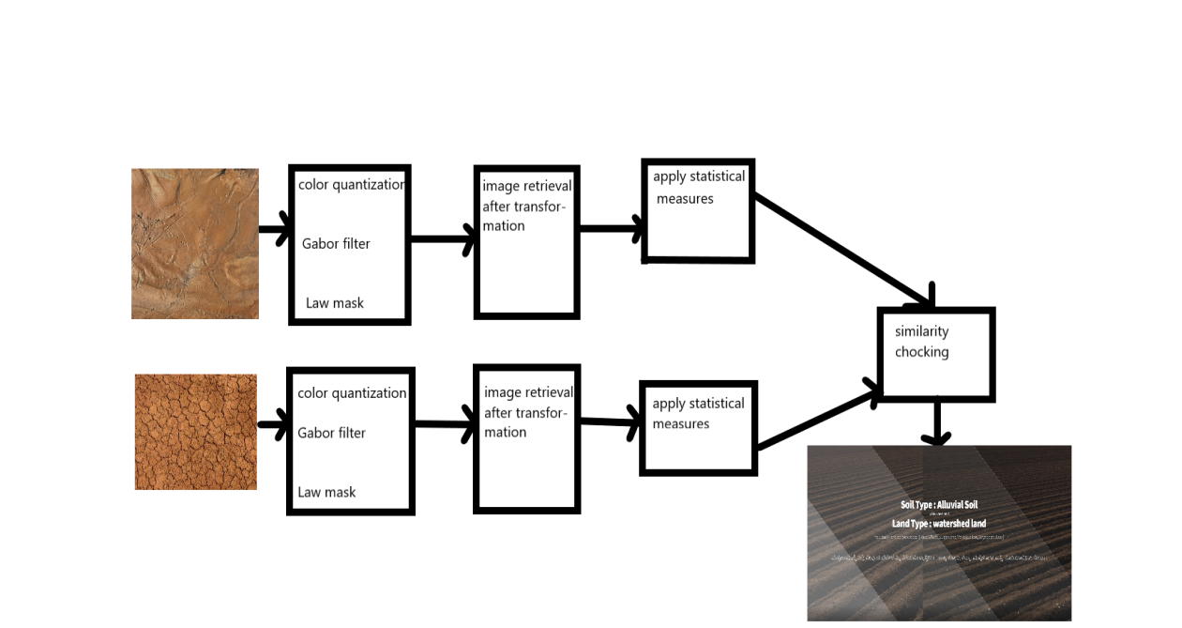

Figure 3.1: Project Architecture of SOIL AND LAND CLASSIFICATION

### DESCRIPTION

**Input Data:** Input data is generally in .jpg format or .png format where the data is fetched and mapped in the data framed from the source columns.

**Reading Data:** Torch vision library is used to read the data into the data frame.

**Separating Features:** In this following step we are going to separate the features which we take to train the model by giving the target value i.e 1/0 for the particular offeatures.

**Normalization:** Normalization is a very important step while we are dealing with the large values in the features as the higher bit integers will cost high computational power and time. To achieve the efficiency in computation we are going to normalize the data values.

**Training and test data:** Training data is passed to the VGG classifier to train the model. Test data is used to test the trained model whether it is making correct predictions or not.

**VGG Classifier:** the purpose of choosing the VGG classifier for this project the efficiency and accuracy that we have observed when compared to other classifiers.

### USE CASE DIAGRAM

In the use case diagram we have basically two actors who are the user and the administrator. The user has the rights to login, access to resources and to view the crime details. Whereas the administrator has the login, access to resources of the users and also the right to update and remove the crime details, and he can also view the user files.

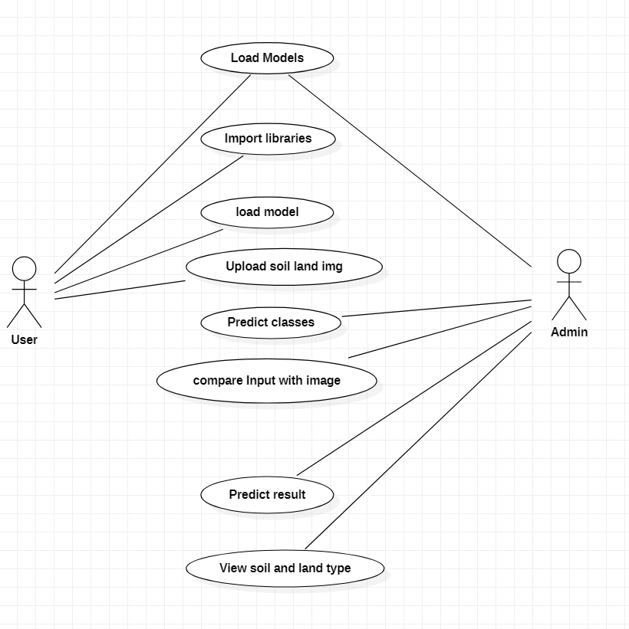

Figure 3.2: Use Case Diagram for SOIL AND LAND CLASSIFICATION

### CLASS DIAGRAM

Class Diagram is a collection of classes and objects.

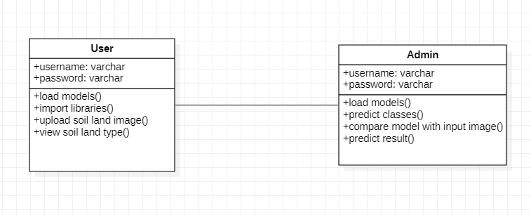

Figure 3.3: Class Diagram for SOIL AND LAND CLASSIFICTION

### SEQUENCE DIAGRAM

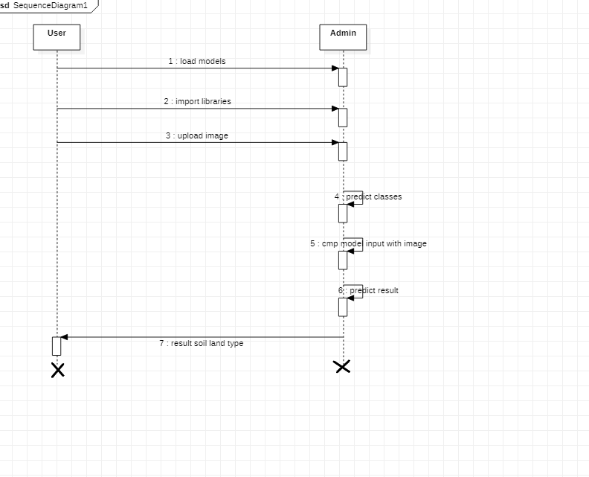

Figure 3.4: Sequence Diagram for SOIL AND LAND CLASSIFICATION

### ACTIVITY DIAGRAM

It describes about flow of activity states.

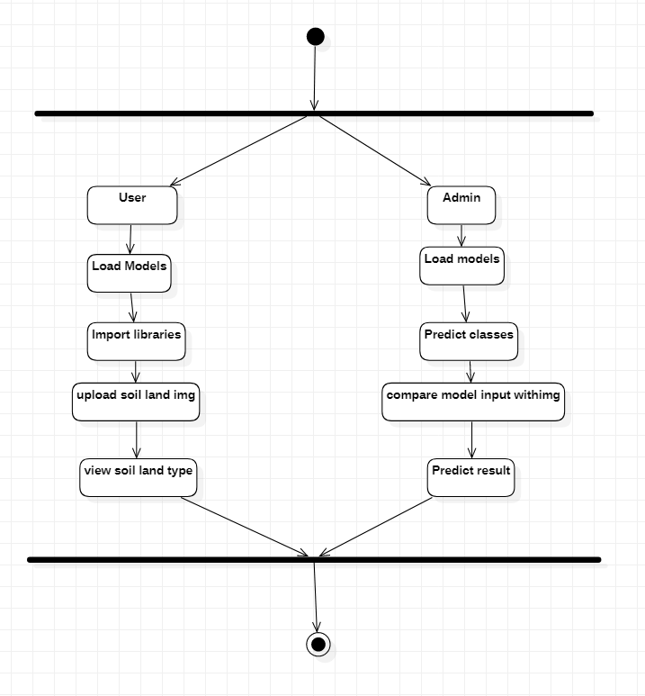

Figure 3.5: Activity Diagram for SOIL AND LAND CLASSIFICATION

# IMPLEMENTATION

### 4. IMPLEMENTATION

### 4.1 SAMPLE CODE

from tensorflow.keras.models import load_modelfrom tensorflow.keras.preprocessing.image import load_img, img_to_arrayimport numpy as npfrom flask import Flask, request, render_templatefrom werkzeug.utils import secure_filenameimport os, sys, glob, reapp = Flask(__name__)model_path = "SoilNet.h5"SoilNet = load_model(model_path)classes = {0:"Alluvial Soil:-{ Rice,Wheat,Sugarcane,Maize,Cotton,Soyabean,Jute }",1:"Black Soil:-{ Virginia, Wheat , Jowar,Millets,Linseed,Castor,Sunflower} ",2:"Clay Soil:-{ Rice,Lettuce,Chard,Broccoli,Cabbage,Snap Beans }",3:"Red Soil:{ Cotton,Wheat,Pilses,Millets,OilSeeds,Potatoes }"}

def model_predict(image_path,model): print("Predicted") image = load_img(image_path,target_size=(150,150)) image = img_to_array(image) image = image/255 image = np.expand_dims(image,axis=0) result = np.argmax(model.predict(image)) prediction = classes[result]

if result == 0: print("Alluvial.html") return "Alluvial","Alluvial.html" elif result == 1: print("Black.html") return "Black", "Black.html" elif result == 2: print("Clay.html") return "Clay" , "Clay.html" elif result == 3: print("Red.html") return "Red" , "Red.html" @app.route('/',methods=['GET'])def index(): return render_template('index.html')@app.route('/predict',methods=['GET','POST'])def predict(): print("Entered") if request.method == 'POST': print("Entered here") file = request.files['image'] # fet input filename = file.filename print("@@ Input posted = ", filename) file_path = os.path.join('static/user uploaded', filename) file.save(file_path)

print("@@ Predicting class......")

pred, output_page = model_predict(file_path,SoilNet) return render_template(output_page, pred_output = pred, user_image = file_path) if __name__ == '__main__': app.run(debug=True,threaded=False)

# USAGE

# python train_mask_detector.py --dataset dataset

# import the necessary packages

from tensorflow.keras.preprocessing.image import ImageDataGenerator

from tensorflow.keras.applications import MobileNetV2

from tensorflow.keras.layers import AveragePooling2D

from tensorflow.keras.layers import Dropout

from tensorflow.keras.layers import Flatten

from tensorflow.keras.layers import Dense

from tensorflow.keras.layers import Input

from tensorflow.keras.models import Model

from tensorflow.keras.optimizers import Adam

from tensorflow.keras.applications.mobilenet_v2 import preprocess_input

from tensorflow.keras.preprocessing.image import img_to_array

from tensorflow.keras.preprocessing.image import load_img

from tensorflow.keras.utils import to_categorical

from sklearn.preprocessing import LabelBinarizer

from sklearn.model_selection import train_test_split

from sklearn.metrics import classification_report

from imutils import paths

import matplotlib.pyplot as plt

import numpy as np

import argparse

import os

#complete packages used in this project

# 5. SCREENSHOTS

### ANACONDA PROMPT

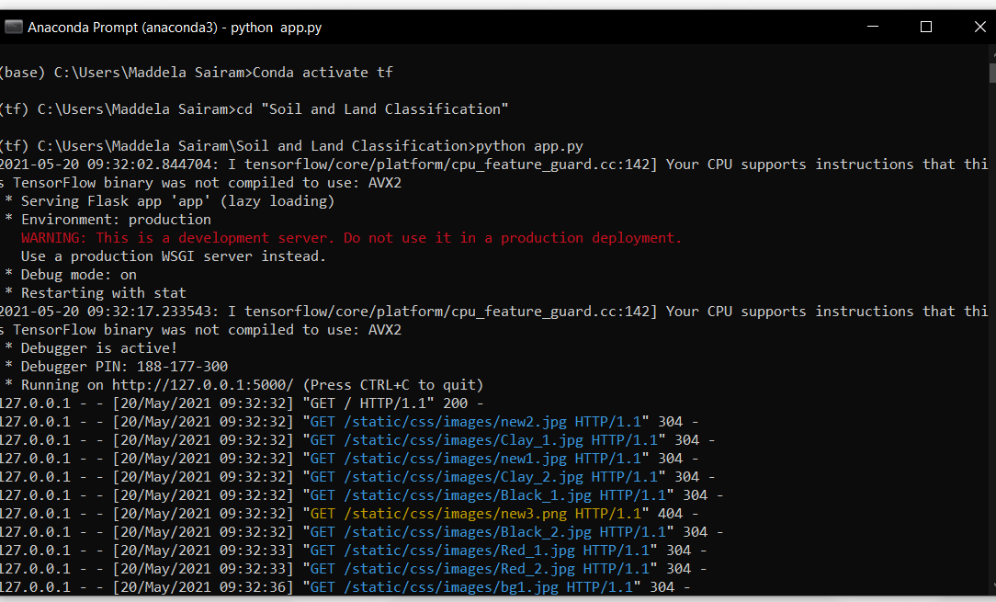

Screenshot 5.1: Anaconda Prompt for SOIL AND LAND CLASSIFICATION

### MAINPAGE

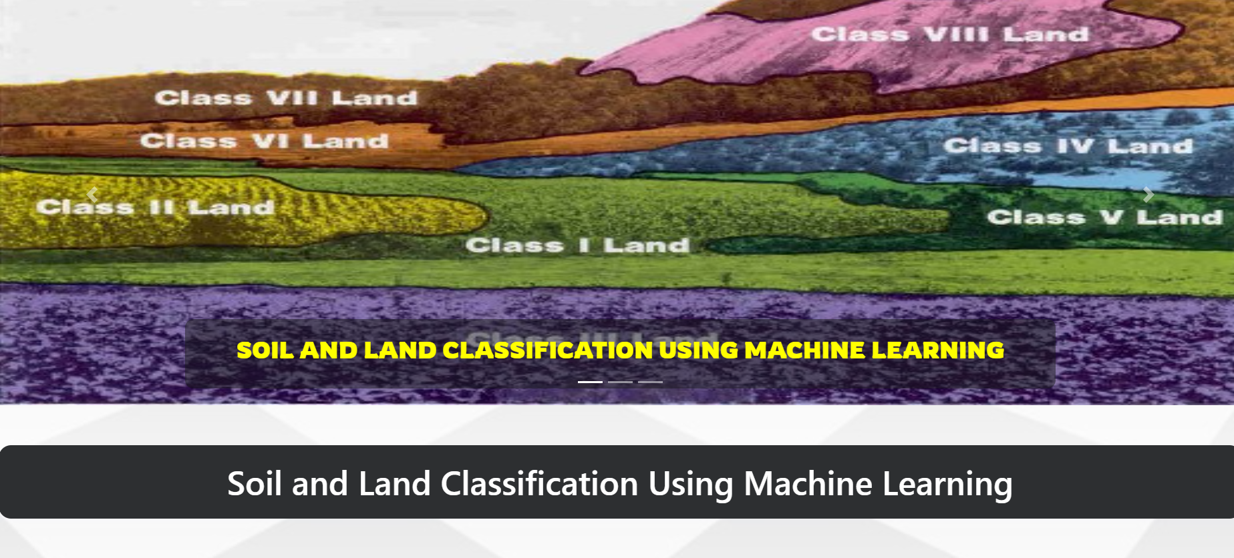

Screenshot 5.2: Main Page for SOIL AND LAND CLASSIFICATION

### PREDICTION



Screenshot 5.3: Prediction Page for SOIL AND LAND CLASSIFICATION

**RESULT PAGE**

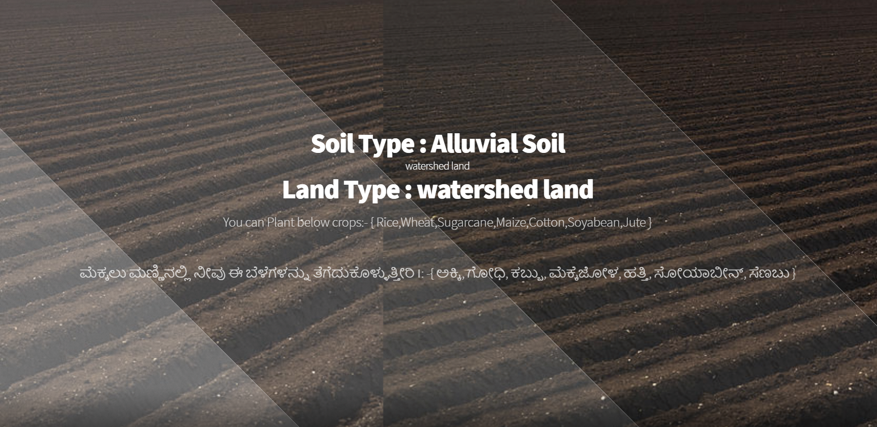

Screenshot 5.4: Result Page for SOIL AND LAND CLASSIFICATION

# TESTING

## TESTING

### INTRODUCTION TO TESTING

The purpose of testing is to discover errors. Testing is the process of trying to discover every conceivable fault or weakness in a work product. It provides a way to check the functionality of components, subassemblies, assemblies and/or a finished product. It is the process of exercising software with the intent of ensuring that the Software system meets its requirements and user expectations and does not fail in an unacceptable manner. There are various types of test. Each test type addresses a specific testing requirement.

### 6.2TYPES OF TESTING

**6.2.1UNIT TESTING**

Unit testing involves the design of test cases that validate that the internal program logic is functioning properly, and that program inputs produce valid outputs. All decision branches and internal code flow should be validated. It is the testing of individual software units of the application .it is done after the completion of an individual unit before integration. This is a structural testing, that relies on knowledge of its construction and is invasive. Unit tests perform basic tests at component level and test a specific business process, application, and/or system configuration. Unit tests ensure that each unique path of a business process performs accurately to the documented specifications and contains clearly defined inputs and expected results.

### INTEGRATION TESTING

Integration tests are designed to test integrated software components to determine if they actually run as one program. Testing is event driven and is more concerned with the basic outcome of screens or fields. Integration tests demonstrate that although the components were individually satisfaction, as shown by successfully unit testing, the combination of components is correct and consistent. Integration testing is specifically aimed at exposing the problems that arise from the combination of components.

### FUNCTIONAL TESTING

Functional tests provide systematic demonstrations that functions tested are available as specified by the business and technical requirements, system documentation, and user manuals.

Functional testing is centered on the following items:

|  |  |
| --- | --- |
| Valid Input | : identified classes of valid input must be accepted. |
| Invalid Input | : identified classes of invalid input must be rejected. |
| Functions | : identified functions must be exercised. |
| Output | : identified classes of application outputs must be exercised. |

Systems/Procedures: interfacing systems or procedures must be invoked.

Organization and preparation of functional tests is focused on requirements, key functions, or special test cases. In addition, systematic coverage pertaining to identify Business process flows; data fields, predefined processes.

### TEST CASES

* + 1. **UPLOADING IMAGES**

|  |  |  |  |  |
| --- | --- | --- | --- | --- |
| Test case ID | Test case name | Purpose | Test Case | Output |
| 1 | User uploads image | Use it for identification | The user uploads the a dog image | Uploaded successfully |
| 2 | User uploads 2nd image | Use it for identification | The user uploads the a non-dog image | Uploaded successfully |

* + 1. **CLASSIFICATION**

|  |  |  |  |  |
| --- | --- | --- | --- | --- |
| Test case ID | Test case name | Purpose | Input | Output |
| 1 | Classification test 1 | To check if the classifier performs its task | A dog image is given | Breed is predicted. |
| 2 | Classification test 2 | To check if the classifier performs its task | A human image is given | It predicted as human. |
| 3 | Classification test 3 | To check if the classifier performs its task | A frog image is given | Predicted as not a dog. |

# CONCLUSION

## CONCLUSION & FUTURE SCOPE

### PROJECT CONCLUSION

This project surveys the different algorithms and methodologies associated with the land classification and in this paper, it has been attempted to identify a method for detecting the nutrient level in the soil. Organic matters play a vital role in soil health. Uses of organic matters are good in séance of increasing water-holding capability and to provide major, minor, and micronutrient to the plant. The good classifier should handle diversity in the land. It should be hierarchical for deep classification with maximum accuracy. The level of nutrients will be helpful for farmers for the further recommendation of fertilizers. Fuzzy Logic with a rule-based system is highly modified and can perform more accurate results of classification. On the other hand, binary classification is a basic and fast approach, however, its accuracy is low as compared to the fuzzy logic system.

### FUTURE SCOPE

The government of India started a scheme ‘Soil Health Card’ promoted by the Department of Agriculture & Cooperation under the Ministry of Agriculture. It will be implemented through the Department of Agriculture of all the State and Union Territory Governments. An SHC is meant to give each farmer soil nutrient status of his holding and advice him on the dosage of fertilizers and also the needed soil amendments, that he should apply to maintain soil health in the long run..

# BIBILOGRAPHY

## BIBILOGRAPHY

### REFERENCES

[1] A. Angelova and S. Zhu. Efficient object detection and segmentation for fine- grained recognition. 2013 Proceedings of the IEEE Conference on Computer Vision and Pattern Recognition, 2013.

[2] J. L. et al. Dog breed classification using part localization. Computer Vision: ECCV 2012, pages 172–185, 2012.

### WEBSITES

[1]<https://web.stanford.edu/class/cs231a/prev_projects_2016/output%20(1).pdf>